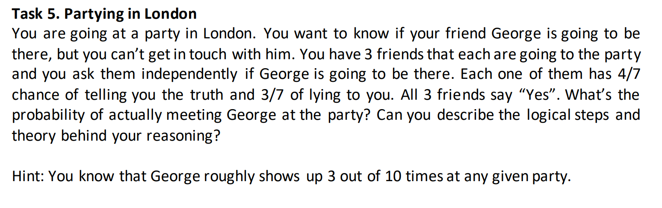

**Answer:**

I ask them if they know if George is going to be there.

How would they know if George is going to be there? (1) George has told them himself. (2) Someone else who always speaks the truth has told them that George is going to be there. We’re going ahead with those assumption, with an additional assumption that George tells the truth about his intentions 100% of the time.

Chances of George showing up at the party are 3/10 given that he had the intention of going to the party in the first place. I can only know about George’s intention from my 3 friends (the reason he doesn’t show up at the party 7/10 times despite his intention could be unknown e.g. his car keeps breaking down). My friends are sort of my sensors of measuring George’s intention.

This problem is akin to the problem of event detection using multiple sensors. Given that all the sensors (my 3 friends here) say that an event has happened, what are the chances that the event actually happened? That would be based on the chances each of the sensors are known to give false-positives. Here, our sensors show true-positives 4/7 of the time and false positive 3/7 of the time. However, given that all 3 sensors (friends) say that the event happened (George had the intention of going to the party), what are the chances that the event actually happened? That would be the opposite of the chances that all 3 sensors are showing false-positives.

Thus, what are the chances that all three of my friends are lying i.e. George never mentioned any intention of coming to the party = (3/7)*(3/7)*(3/7). Thus the chances that George did have the intention of coming to the party = 1 – ((3/7)*(3/7)*(3/7)).

Now that we’ve established that, what are the chances that George will “actually” come to the party, which is an independent event by itself, and has a probability of 3/10.

Thus the chances of me actually meeting George at the party = (3/10)*( 1 – ((3/7)*(3/7)*(3/7))) = 0.27638483965, or roughly 27%